UART-USB Converter Device Driver (FT232)/(Prolific):
To program in Manual mode: and connect the USB cable to PC. To make the board enter programming mode:
- Verify in Windows -> Control Panel-> 1.Device Manager-> 2.Ports-> Right click ->3. Properties-> 4.COM Port Number-> - Set to COM 3 (If not detected install FT232 device driver: CDM v2.10.00 WHQL Certified extract and give the path two times)

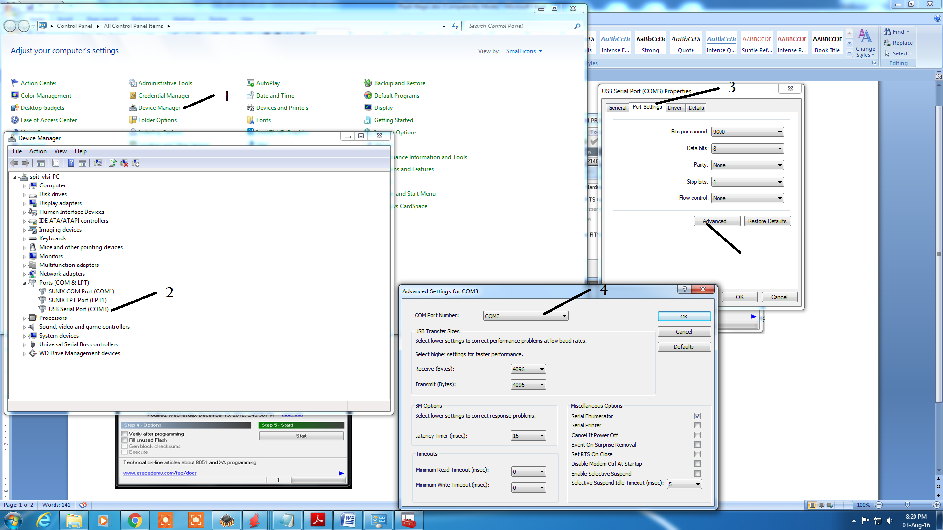
ARM-7 Programming using Flash Magic:
- I- ON ISP ( Switch ON to make it ISP Mode)
- Press RESET button of ARM-7 Board (the controller enters the boot loader mode if during RESET the ISP pin is low)
- Flash Magic Settings:
- Select Device: LPC2148
- COM Port: COMxx (As per Device Manager Indication)
- Baud Rate: 9600
- Interface: (None) ISP
- Oscillator: 12 Mhz
- Erase Blocks used by Hex file: yes
- Advanced Options: Use DTR and RTS to control RST and ISP pin: NO
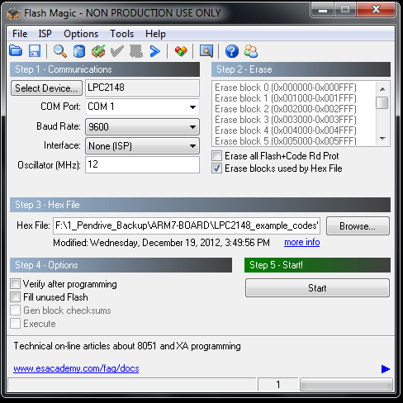
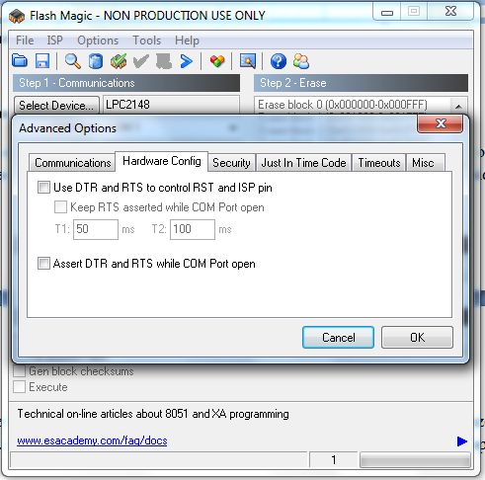
- Browse - > .HEX file -> Start (wait for Programming finished message to display)
- Switch OFF ISP Switch
- Press REST button to execute the program

8051 Programming using Flash Magic:
- HOLD the RESET button (do not remove your finger)
- Flash Magic Settings:
- Select Device: 89V51RD2 (5th IC from bottom)
- COM Port: COMxx (As per Device Manager Indication)
- Baud Rate: 9600
- Interface: (None) ISP
- Oscillator: 11.059 Mhz
- Erase Blocks used by Hex file: yes
- Advanced Options: Use DTR and RTS to control RST and ISP pin: NO
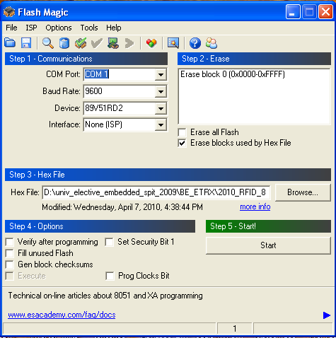
- Browse - > .HEX file -> Start (wait for Programming finished message to display)
- Remove your finger from RESET button
- Press REST button to execute the program

